|  |  |
| --- | --- |
| A picture of a winding road and trees  CASCADING STYLE SHEET | FARZANA |

6/26/2023

**EX 1:**

EXTERNAL CSS:

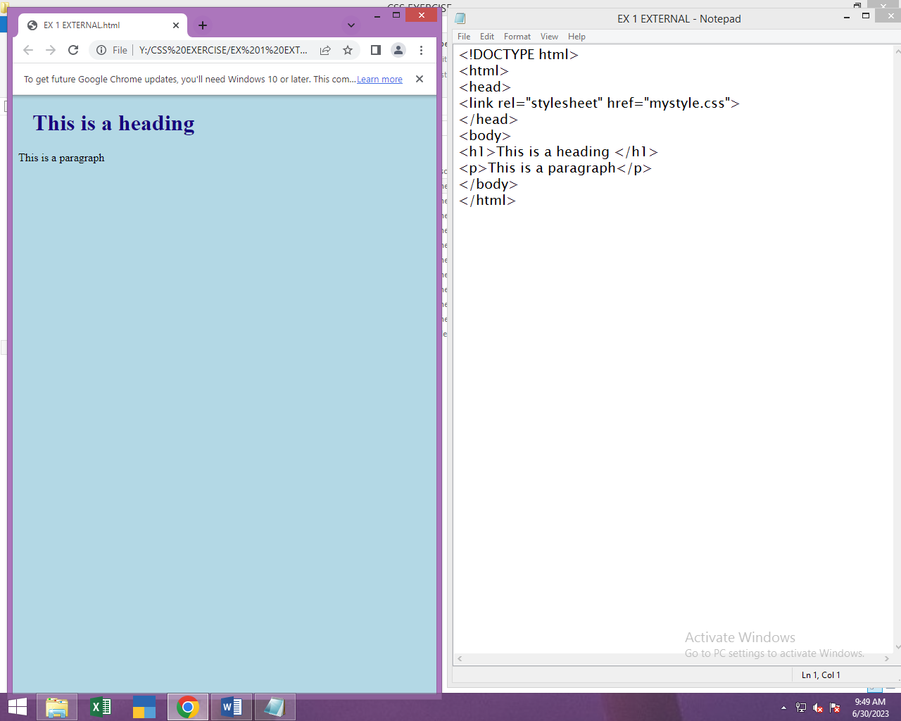

EX 2:

INTERNAL CSS:

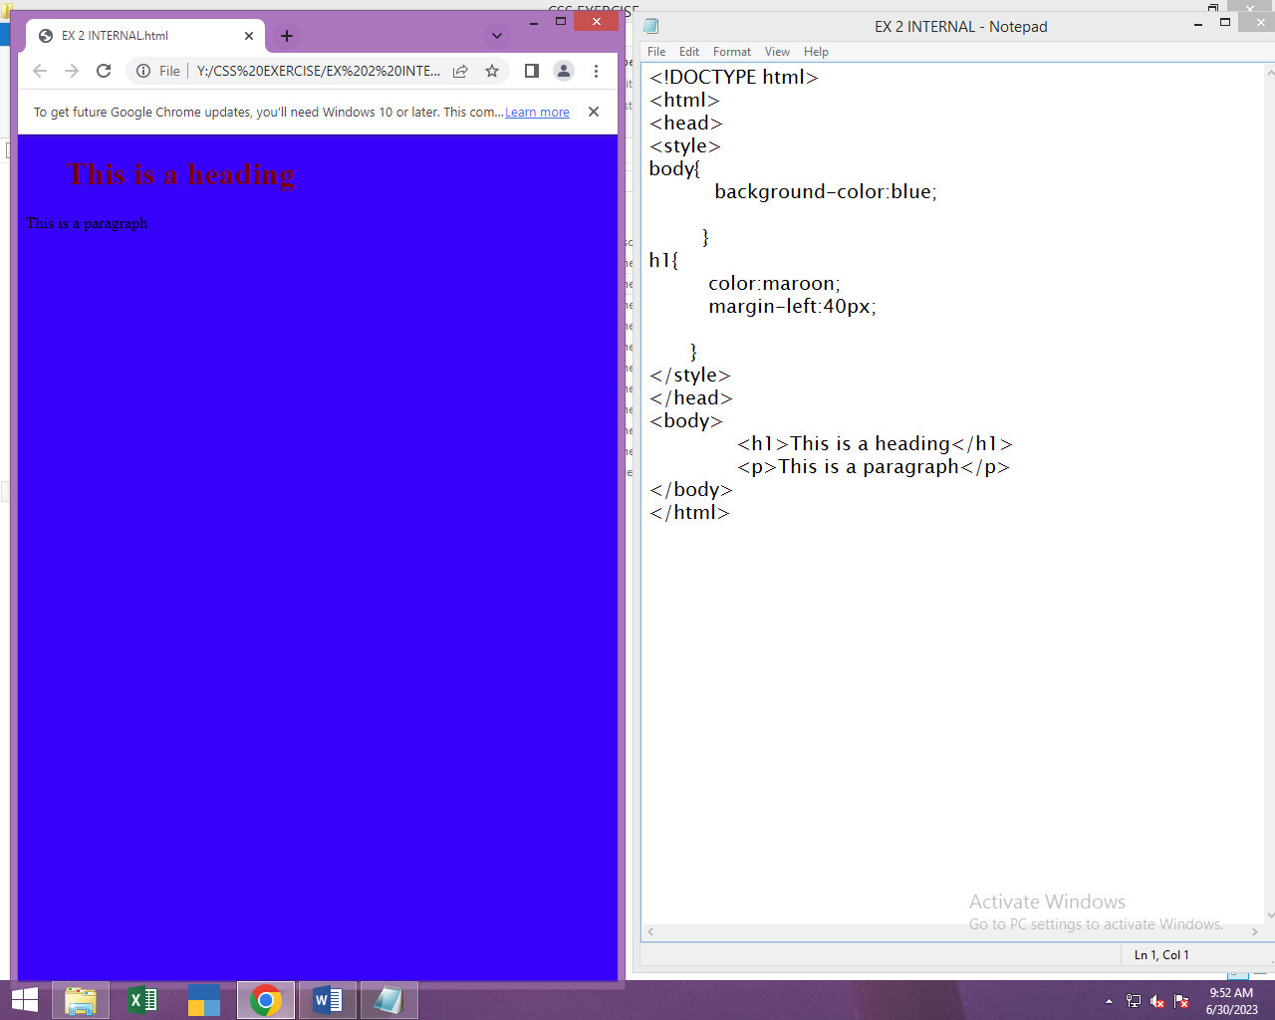

EX 3:

INLINE CSS:

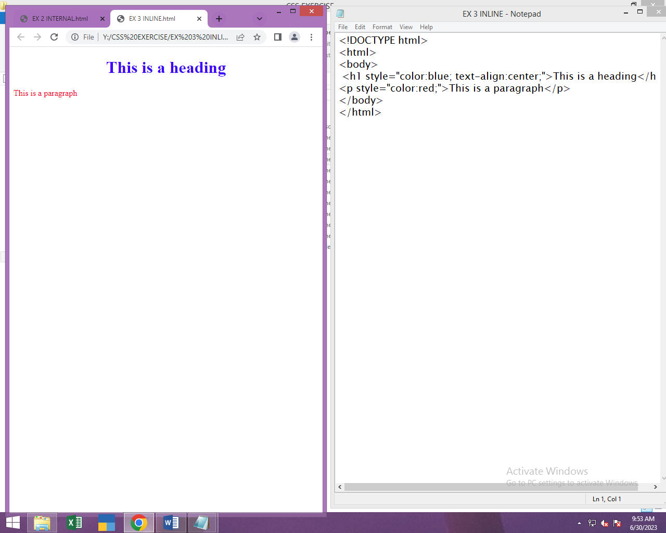

EX 4:

BACKGROUND COLOR:

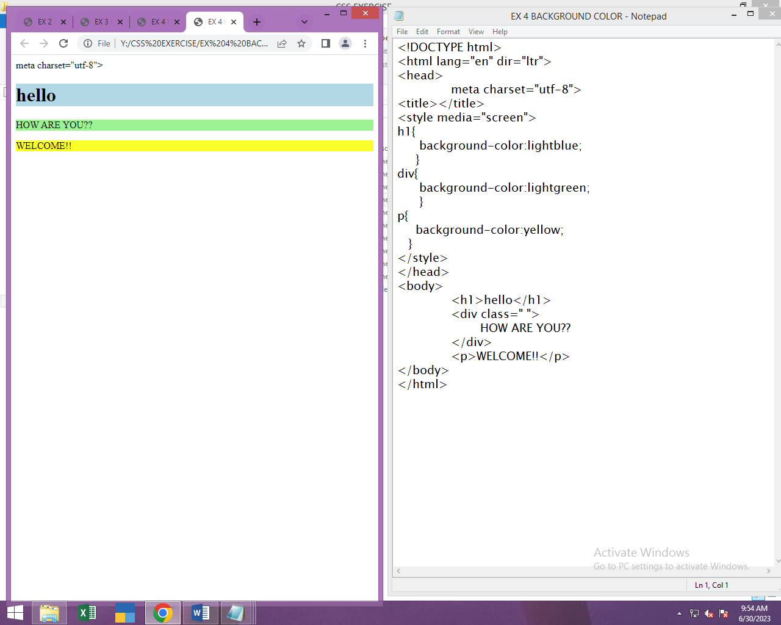

EX 5:

BACKGROUND IMAGE: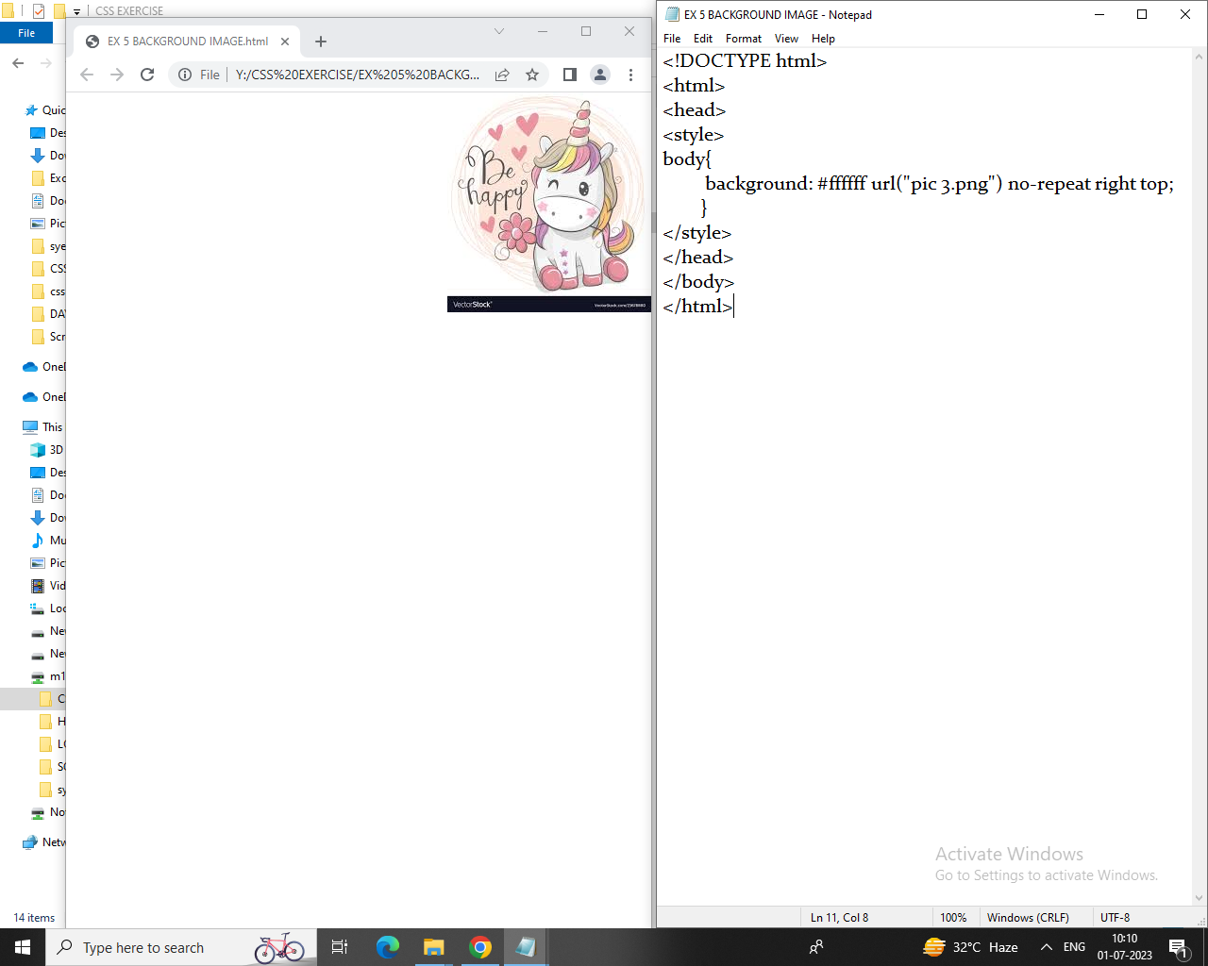

EX 6:

BORDER:

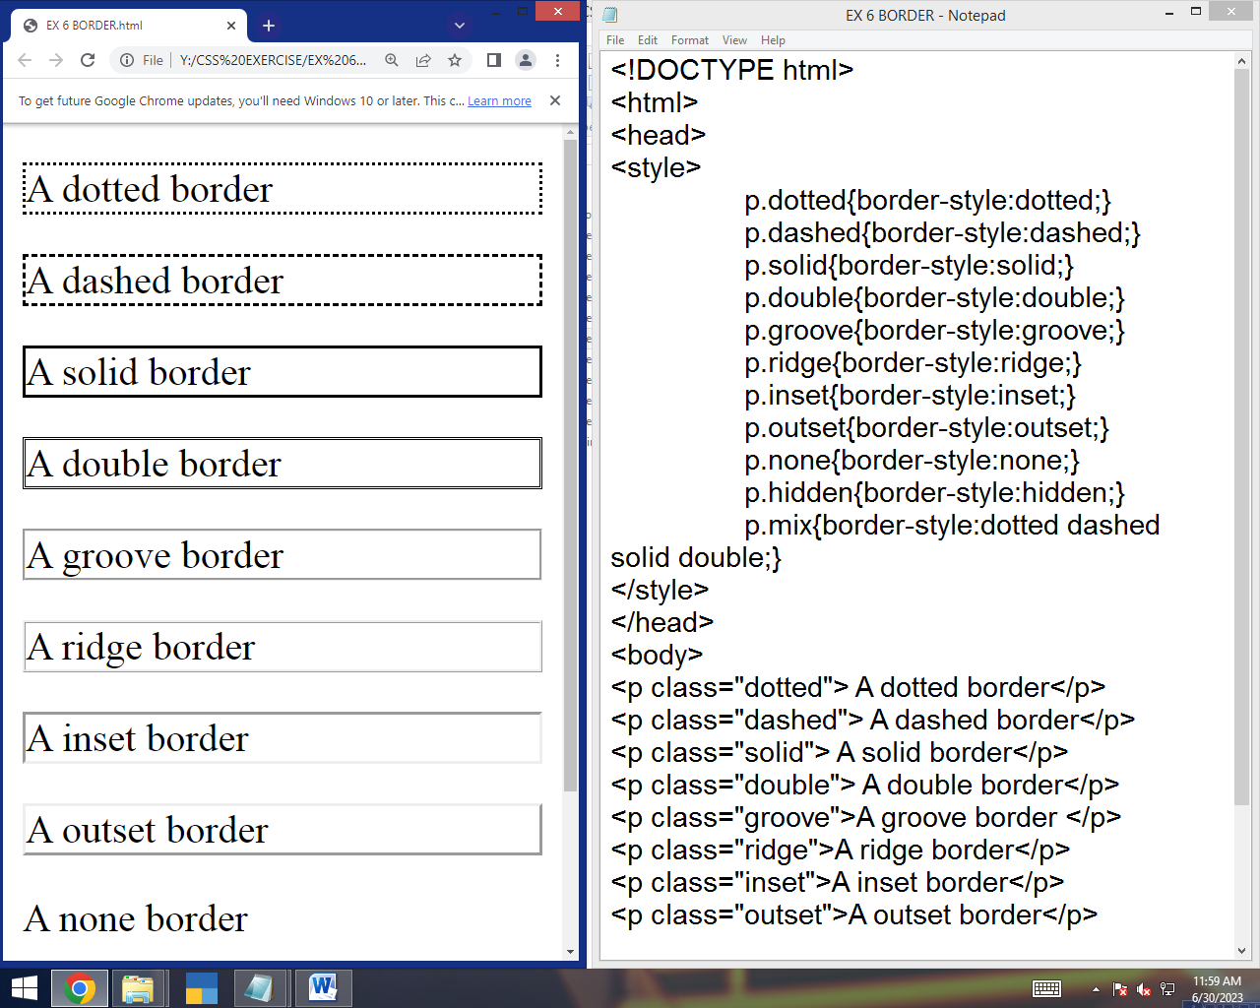

**EX 7.1:**

**LIST WITH STYLES:**

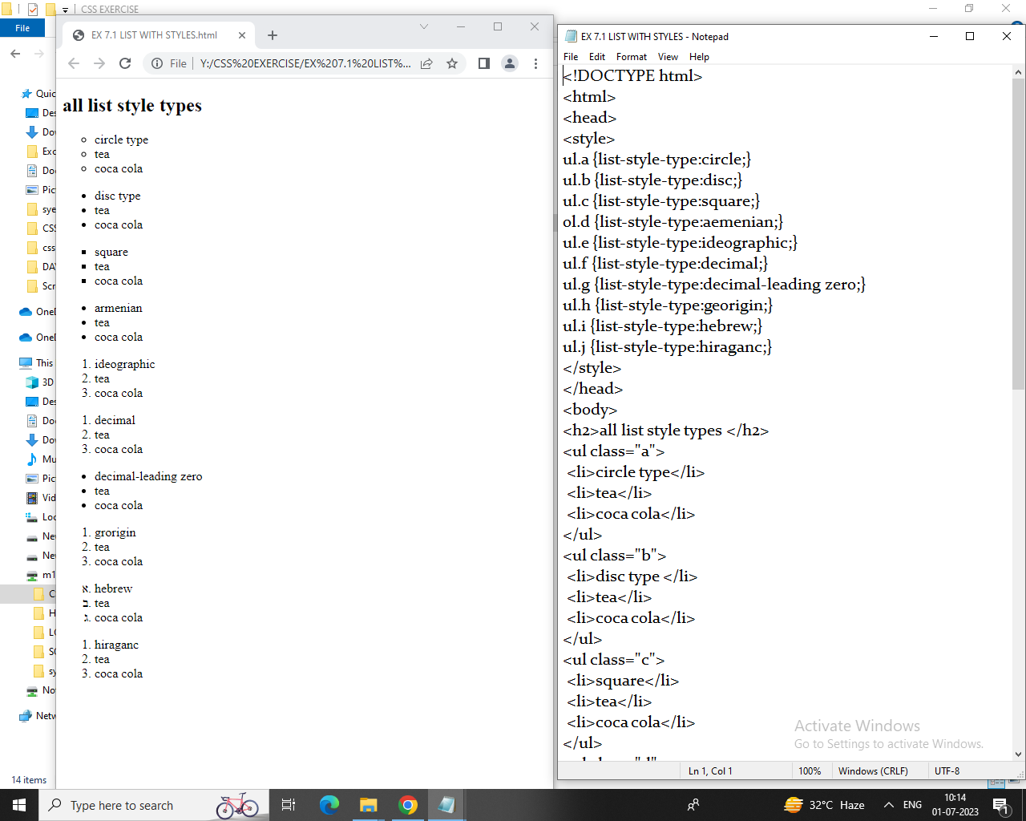

**EX 7.2:**

**LIST WITH COLORS:**

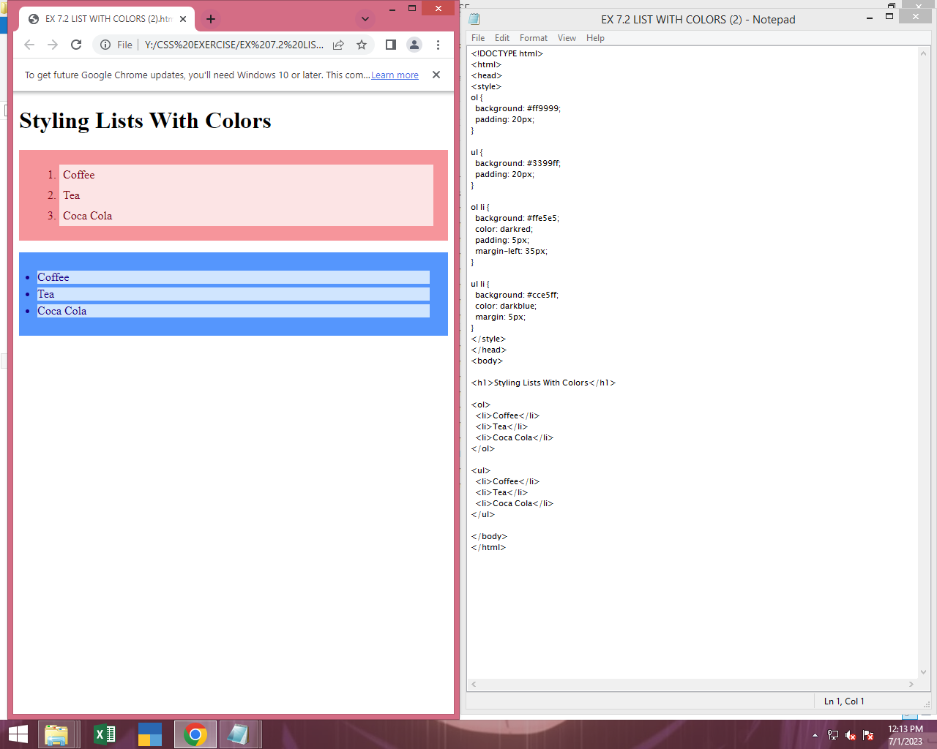

**EX 8:**

**TABLE WITH STYLES:**

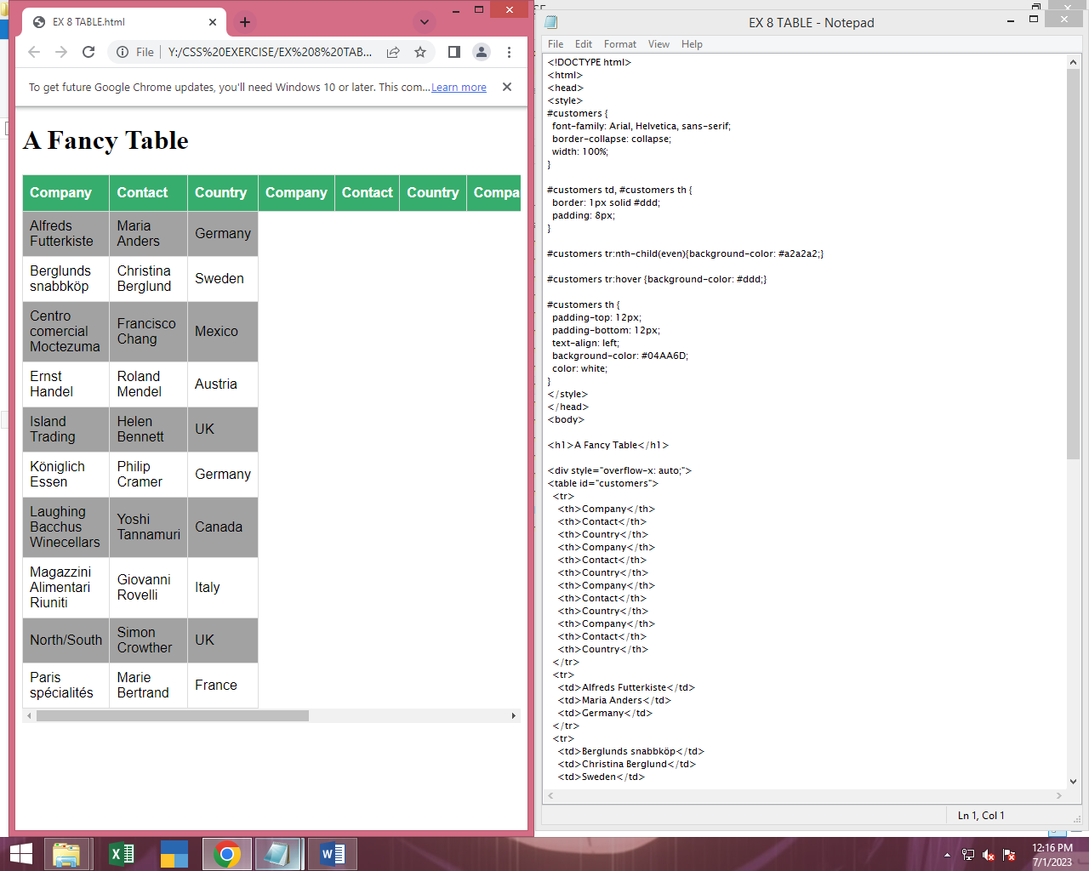

**EX 9:**

**FORMS:**

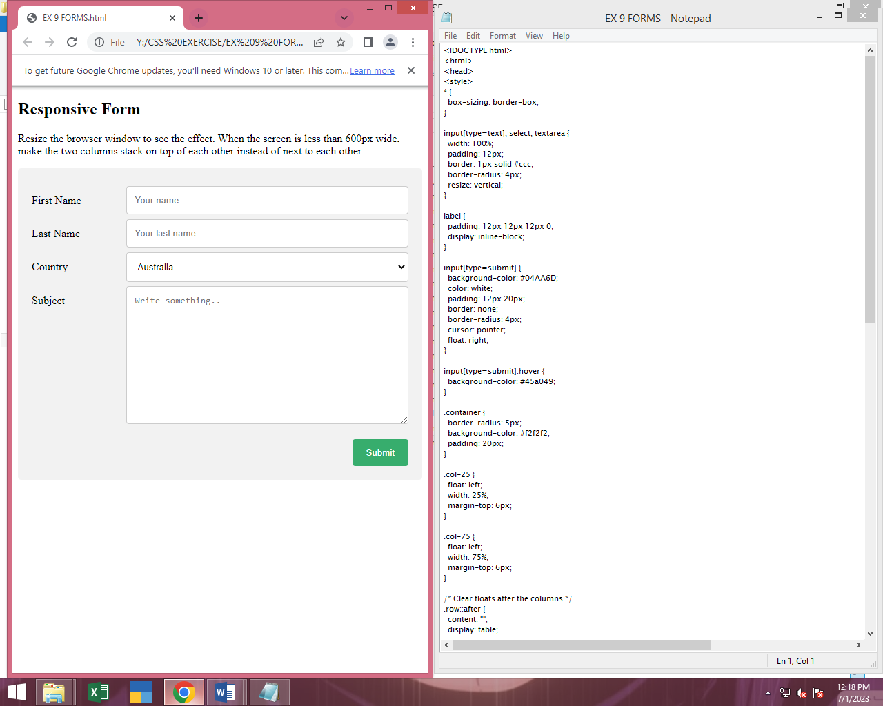

**EX 10:**

**VERTICAL NAV BAR:**

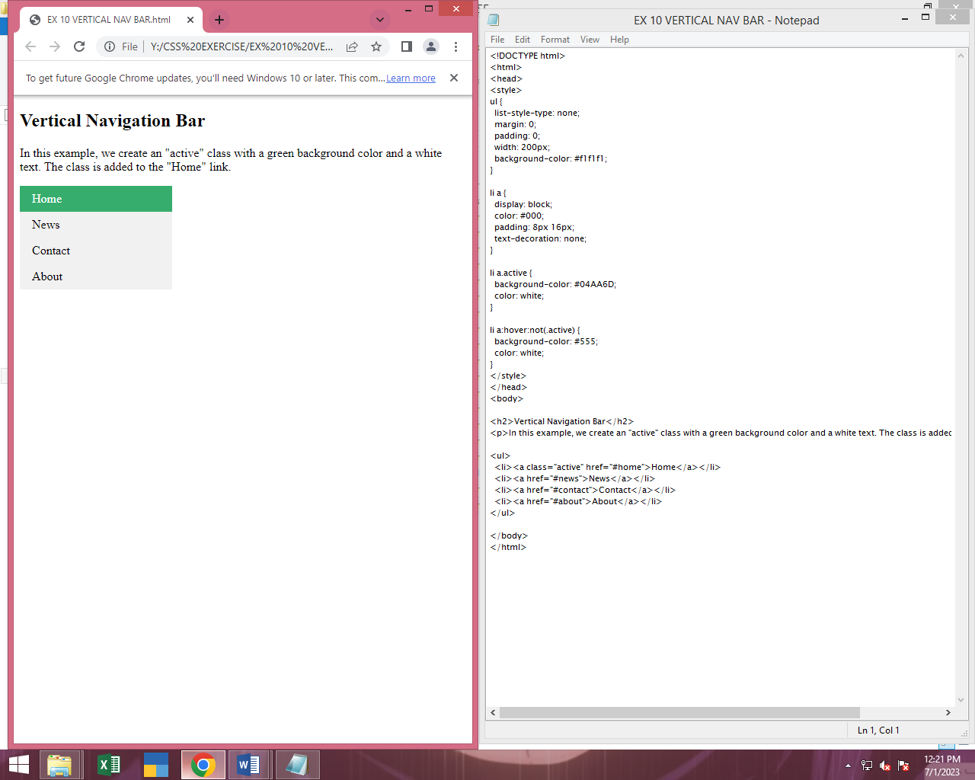

**EX 11:**

**STICKY:**

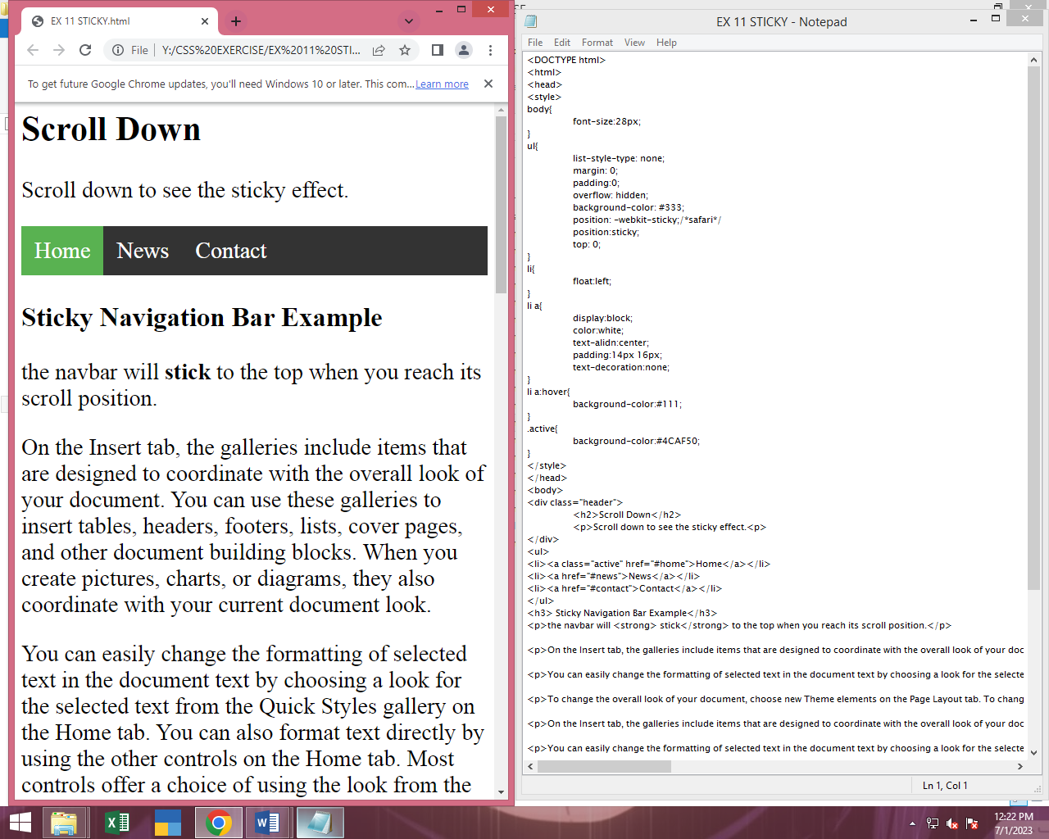

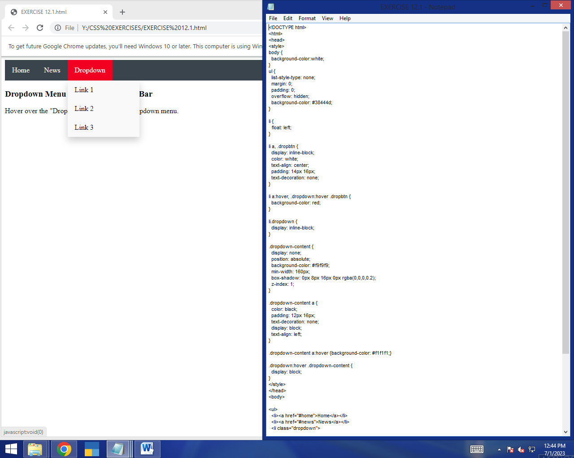

**EX 12.1:**

**DROPDOWN NAVIGATOR BAR:**



**EX 12.2:**

**DROPDOWN IMAGE:**

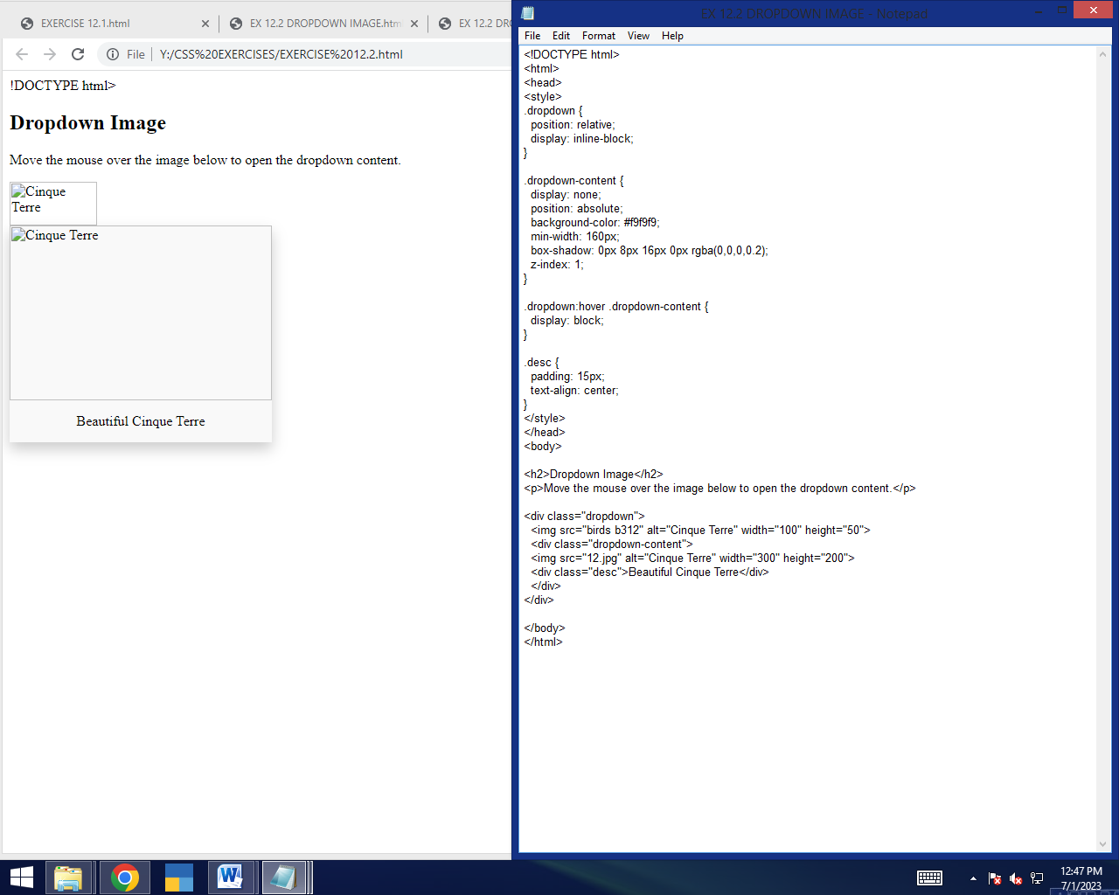

**EX 13:**

**TRANSITION:**

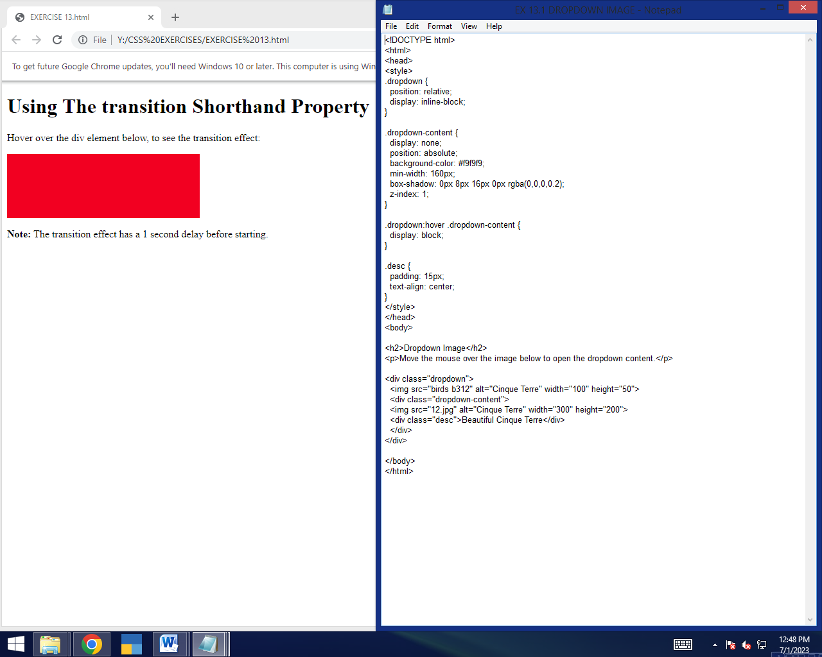

**EX 14:**

**ANIMATION:**

